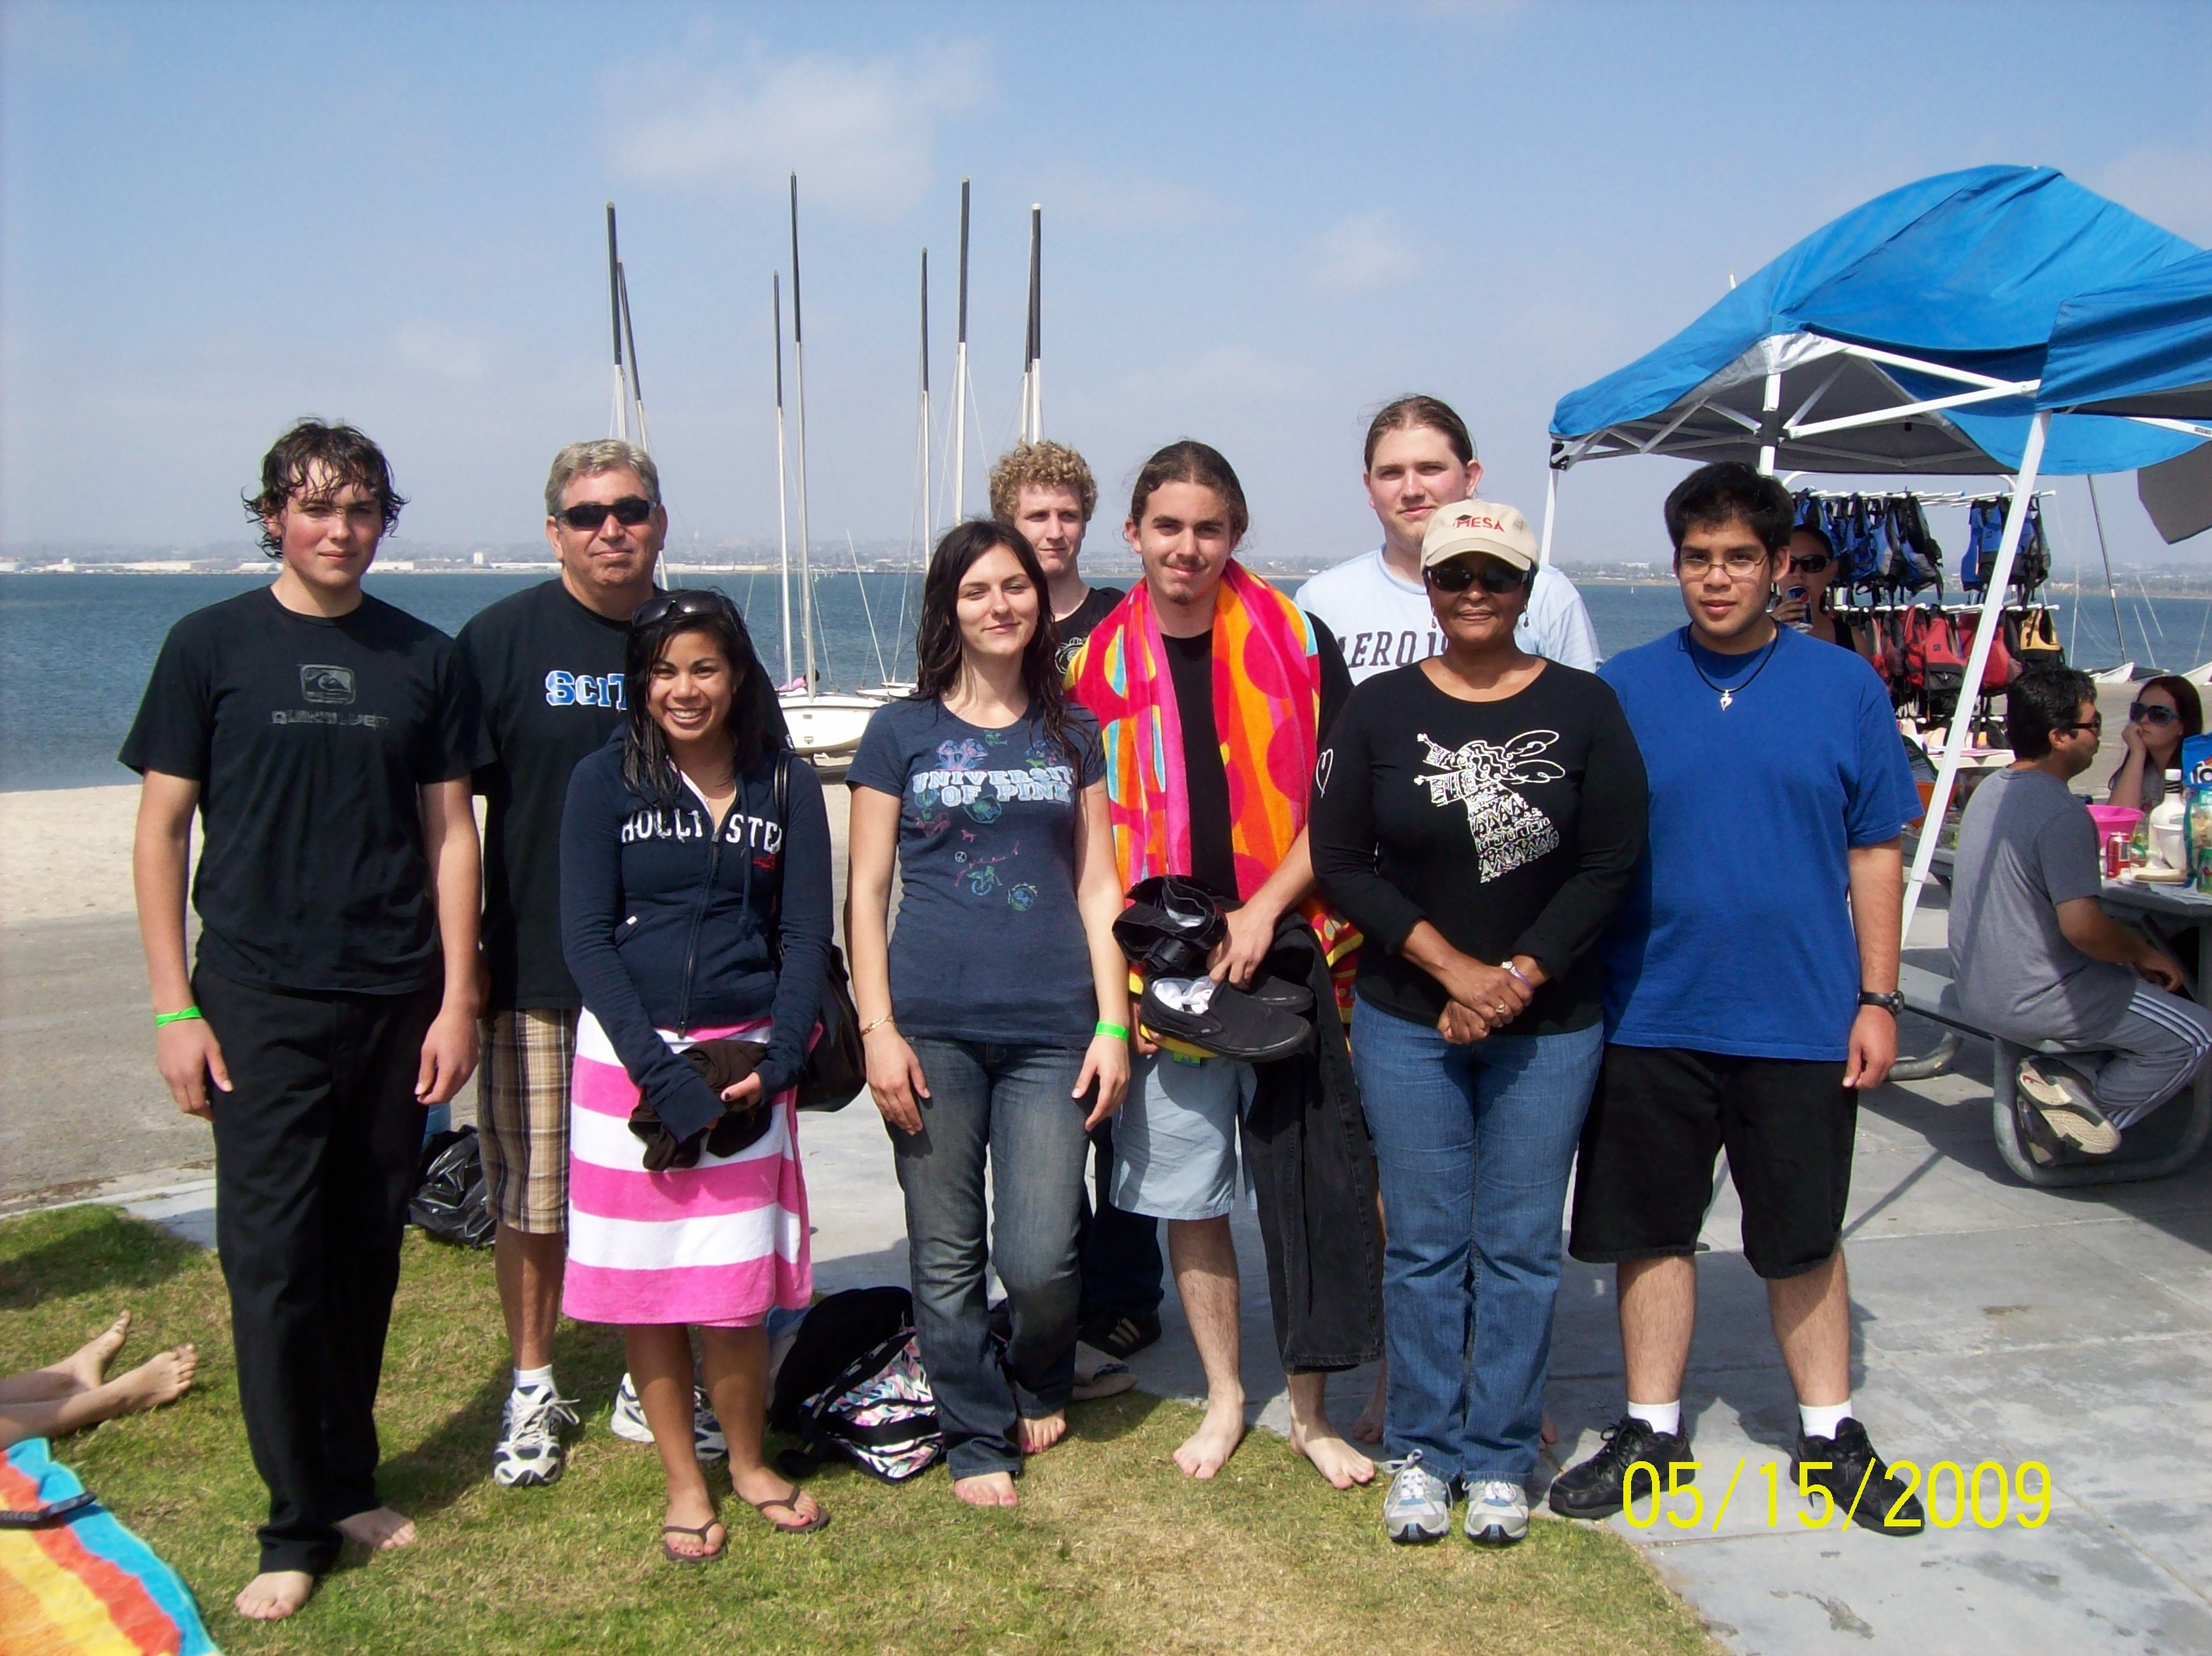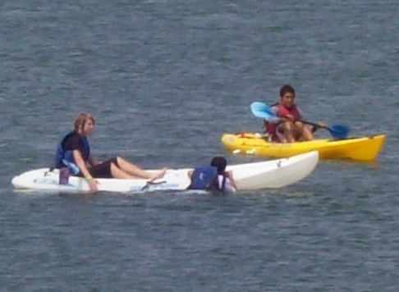

San Diego *MESA* Alliance

End of Year Celebration & Awards

Friday, May 14th (1:00 p.m. – 5:00 p.m.)

(Pick up parking permit at ranger booth, be sure to put on your dash)

WHO?
- MESA IAB (Industry Advisory Board) members and their families
- MESA Students from schools, colleges and universities in the San Diego MESA Alliance (and families)
- Faculty from schools, colleges and universities in the San Diego MESA Alliance (and families)
- SHPE – SWE –AMSA – BIOLOGY CLUB – GORI - CHEM CLUB – NSBE – SDS – PASE – others

WHAT?
- An End-Of-Year Celebration!!
  - Kayaking / Sailing / Volleyball / Swimming / AWARDS / Relaxing / Fun / Food!
  - An opportunity for MESA students, college faculty, and local industry (and their families) to get to know one another.

WHEN?
- Friday, May 14th (tentative schedule below)
  - 1-3pm food, socializing/networking, kayaking, sailing, fun
  - 3-4pm Student Award Presentations
  - 4-5pm Students vs Faculty/Staff/Industry – Volleyball Game

WHERE?
- Southwestern College’s Crown Cove Aquatic Center – Silver Strand State Beach (SSSB)
  - DIRECTIONS
  - Interstate 5 to Palm Ave (Highway 75) West
  - Palm Ave (75) West to Highway 75 Silver Strand Highway
  - Hwy 75 North to Coronado Cays Blvd/Silver Strand State Beach exit
  - Turn left (West) enter Silver Strand State Beach
  - Frontage road North to parking lot # 3
  - Park in the North East corner of the lot # 3 (must RSVP to invite to obtain parking pass)
  - Walk through pedestrian tunnel (East) to CCAC on the Bayside of SSSB

WHY?
- WE ALL DESERVE IT!
QUESTIONS? Contact Dr. Raga Bakhiet: 619.482.6381; rbakhiet@swccd.edu 

