Understanding Energy:
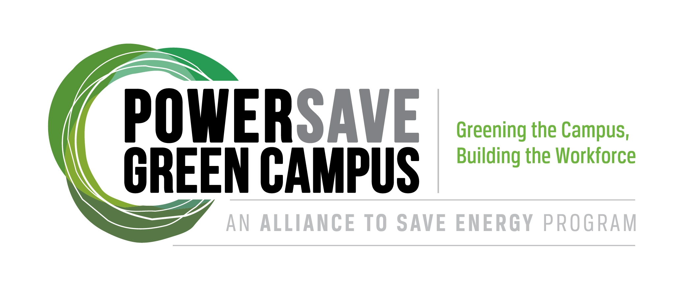
A Lesson Plan for the MESA Green Academy

Objectives:
Define energy and its different sources.
Discuss how to save energy at home via simple behavioral changes.

Introduction:
Student 1: Hello! My name is {Student 1 name} and this is {Student 2 name}. We are here today from {your campus} with the MESA Program to talk to you about energy conservation.

{Insert some personal background about yourself here –what you’re studying, what the MESA program is, and why energy savings is important to you.}

Student 2: Now that you know who we are, it’s time for us to get to know you!

Icebreaker (5 min, slides 2-11):
Materials needed:
Small, squishy ball for tossing
Instructions:
In order to test the students knowledge of energy concepts, explain to the students that they’re going to play a quick game. Explain to the students that you will first throw the ball to a student at random. Once the student catches the ball they will have to state their name and answer a question regarding energy. The questions will be on the first 10 slides of the powerpoint, one question per slide. Once the student answers the question, they will throw it to another student, who will answer the next question and so on. Go through this process until all the questions on the slides are finished.
_____________________________________________________________________________
What is Energy? Discussion (5 min, slide 12):
Student 1: So who can tell me what energy is? {Make sure you ask this question before you turn to the slide discussing Energy. Wait for answers from students, and when they answer, don’t acknowledge quite yet if they are right or wrong, instead just say, that’s a good idea, etc.}

Student 2: Okay, well who can tell me examples of how we use energy? {Wait for more answers, and acknowledge each one with enthusiasm. Answers may vary from “Running in a race” to “Turning on a toaster,” and so forth.}

Student 1: {Turn to slide 12 as you begin talking.}You are all exactly right. Energy is all of those things. We use energy when we lift heavy objects, or flip on a light switch. In short, energy is the ability to do work. Energy is used when we move something, lift something, warm something, or light something.

Student 2: However, I bet you all have noticed that it is a lot easier to use energy by turning on a light than it is when we lift something heavy. Because of this, we’re often a lot more wasteful of electricity or gasoline for instance, then we are when we actually have to produce our own energy, such as riding a bike for instance.

_____________________________________________________________________________
Sources of Energy Discussion (5 min, slide 13):
Student 1: It seems like you all know quite a bit about energy and electricity. Now we’re going to take some time to talk about where our electricity comes from and why it matters to our environment.

Student 2: Does anyone remember the different sources of energy (renewable or non-renewable)? (Wait for a few seconds, take hands to get answers).

Student 1: That’s right. This slide is a reminder of the different sources of energy. It is divided into renewable and non-renewable sources. (Show slide with renewable/nonrenewable).

Student 2: Electricity is also a source of energy, but it is called secondary energy because we need to use these (pointing to the slide) sources to create electricity. Power plants are the places where we turn these primary sources of energy into electricity.

Student 1: A common example of a power plant in the United States is a coal-fired plant. These are only 35% efficient. Does anyone know what it means for a coal-fired plant to be 35% efficient? (Wait for hands, take answers).

Student 2: (Depending on responses that students gave do a “that’s right!” or “you’re getting close”). A coal-fired plant is only 35% efficient because it takes 35% of the potential energy stored in coal and converts it into kinetic energy that can be used to create electricity. What happens to the other 65% of the energy stored in coal?

Student 1: The other 65% of the energy is released in the form of byproducts like soot, nitrogen dioxide (which causes acid rain), and other greenhouse gases that are responsible for the depletion of the ozone and global warming.

Student 2: The rest of the non-renewable sources of energy are used to create electricity in a way that’s similar to coal. This is the important difference between non-renewable and renewable sources of energy. Renewable sources of energy (like solar, wind, etc. referencing the presentation) can be used to generate electricity without creating the harmful byproducts that are the result of burning coal or other non-renewables.

Student 1: Most of the electricity we use in our everyday lives is generated by coal and non-renewable power plants. Whenever we turn on the lights, watch tv, take a hot shower, or heat our homes, we are contribution to the pollution of the environment.
_____________________________________________________________________________
Oatmeal Activity (15 min, slide 14)

Student 1: Now we’re going to do an activity that illustrates the inefficiencies of electricity generation.

Student 2: We’ll need you all to stand up in a big circle.

Find one person to start the oatmeal activity as described below.

What you need:
-student volunteers
-Oatmeal
-Bucket
-Broom, vacuum, etc. to clean up (ask custodial staff/organizer before hand)
Activity summary:
Ask the student volunteers to represent each point in the transportation process. Have students stand in a circle around the classroom. Refer to the transmission and distribution slides as reference. You will need a bucket to collect the “energy waste” (falling oatmeal) which will be placed under the hands of the students who are passing on the oatmeal.

The experiment starts off by pouring a large handful of oatmeal into the hands of a student, preferably someone with big hands to symbolize the first point of production at the power plant. It’s ok if some oatmeal falls in the bucket. Ask each student to pour the oatmeal into the next student’s hands. In the end, at least half of the original oatmeal “produced” should be in the bucket. At the end of the experiment, show the class how much oatmeal or “energy” was lost during the process. Explain that in real life, a much larger percent of energy is lost as waste than the actual experiment.

Student 1: {Stand at the beginning of the line of students where the very first student who had the original handful of oats is at.}As you can see, the amount of oatmeal dropped significantly as it went through the process of getting passed down the line. We can relate this to energy production because a little bit of energy is wasted at each step in the process from the power plant to you. For instance, lets say{gesture toward first student} that (insert student name here), represents a coal power plant, where the cycle starts. The electricity here is not generated efficiently, meaning that we lose a lot of energy just in this very first step alone. In fact, coal power plants are only about 33% efficient so the majority of energy is actually lost right here!

Student 2: {Stand at the end of the line next to the very last student.} In addition, after generation, the electricity has to be transmitted from the power plant to our homes. As it moves through the power lines, even more is wasted, and the vast majority of the potential energy from our primary energy sources is never realized as electricity. And as you can see, about half of the oatmeal in this experiment made it to the end of the line. However, in an energy system much more than half is wasted.

{At this time, get all students back to seats and quieted down to begin the next portion of the presentation.}
____________________________________________________________________________
Why Save Energy? (2-3 min, slide 15)

Student 1: Why does saving energy matter to each of you as an individual? Why should you care if energy is wasted?

Student 2: We have already discussed the harmful byproducts of energy generation so you all know that power plants fueled by non-renewables emit hazardous greenhouse gases like carbon dioxide and methane. But even if the environment itself isn’t your primary concern, there are still plenty of reasons to save energy.

Student 1: Energy, especially electricity, is expensive! San Diego has especially high electricity prices that range from 16.4 cents in the winter to 25.5 cents per kwh in the peak of the summer. A quarter may not seem like very much, but when you start to think about all of your appliances that use electricity (lights, refrigerator, dishwasher, washer/dryer, water heater, tv, computer, heating, air conditioning, toaster, microwave, cell phone, video games...ahhhh!), it really starts to add up!

Student 2: If you’re smart about your electricity use, you can save at least $50 per month on the bill, and maybe even more depending on how much you currently use.
Student 1: Reducing your energy use will not only save you money right now, but in the future. The harmful effects of non-renewable energy production deplete the environment, and this is a cost that we will all have to pay in the future. When our environment is damaged, we not only have a worse quality of life, but it is expensive to repair! (Higher taxes).

Student 2: I bet by this point you would like us to tell you how you can save money and the environment at the same time. Well, we have some suggestions! (If the students live at home suggest that they start an energy saving program with their families. If the student can lower the energy bill by $50 per month, maybe their parents will let them keep ½!)

_____________________________________________________________________________
What you can do to save energy? (5 min, slides 16-17)

Student 1: There are tons of simple ways that you can reduce your energy use, many of which involve only simple behavioral changes. Sometimes these changes can be the hardest, because they require minor tweaks to your everyday life. However, its this area of energy efficiency that offers the most potential energy savings.{Review the bullet points listed on slide 16 one by one. Review each small behavioral change that each student can do to save energy.} If you’re having trouble remembering to implement these changes, leave yourself a reminder! Sometimes a note to turn off the light next to the light switch will help you remember every time you leave the room. You can also remind your family and friends as well.

Student 2: {Change to the next slide, slide 17.} On the other hand, there are some immediate fixes that can be implemented around your house as well - no reminders required! {Review each of the bullet points on slide 17, one by one, which reviews technical energy saving fixes. Remind the students (if they’re in high school) that they can check in with their parents about making these updates throughout their home.} The most common out of all these fixes however, is the simple light bulb switch. Next we’re going to show you why that fix is such a great way to save energy.
_____________________________________________________________________________
The Light Bulb Display Activity (5 min, slide 18)

Student 2: {Make sure that the light bulb display is sitting at a table/desk at the front of the class where it can be seen, and that it is plugged in. At this time, all the lights should be off.}

Student 1: {While Student 2 is making sure the display is ready} So I have here with me today a lighting display with three types of lights. Can anyone tell me what these types of lights are called? {Wait for answers, call on students. Explain again what each type of light is called (incandescent, compact flourescent (CFL), and LED lights) whether they gave the right answer or not.}

Student 2: Well who can tell me which one is the least efficient? {Wait for answers, some will probably identify the incandescent.} Great! That’s right. And right now we’re going to demonstrate why. Can I get a couple volunteers to come to the front of the class? {Guide the volunteers up the front next to the lighting display.}

Student 1: Thanks for volunteering! {Turn on the CFL and the incandescent - warn the students it might be bright first.} Now, I want both the volunteers to put their hands close to both the CFL and the incandescent - but don’t touch the bulb! Do you feel a difference between the two bulbs? {Both will probably say something along the lines of, the incandescent is much warmer than the CFL.} Exactly, the incandescent is much warmer than the CFL.

Student 2: Great, now what’s the difference between these two? {Turn on the LED and turn off the incandescent, keep the CFL on.} Right - the LED is even cooler than the CFL. Can anyone tell me why these bulbs have different temperature levels? {Direct this question to the whole class. Wait for answers from students, if they have any, regardless of whether you get the right answer or not make sure you repeat the correct answer aloud so the whole class can hear.} The hotter the bulb is, the more energy its wasting as heat rather than light. So the LED light and the CFL are much more efficient that the incandescent bulb is, because they use less energy just creating light, rather than having to use extra energy heating the lamp as well. {At this point, you can let the volunteers go back to their seats.}

Student 1: Exactly. That’s why if you see any of these guys {gesture to the incandescent bulb} in your house, try and swap them out for a CFL immediately. CFL’s are inexpensive and are the easiest swap for incandescent bulbs.

Possible Career Paths (3 min, slide 19)

Student 1: Many of you may be wondering how you can apply all these interesting subjects and issues into viable jobs and careers. And, whether it’s even possible.

Student 2: The good news is it is! And that this field of work is growing. Opportunities to join the green workforce are popping up, especially in California. Although, like any other job you’ll have to search for openings and do your own research for hiring companies.

Student 1: {Direct students attention to the slide, with a list of possible jobs and green industries} As you can see on the slide, the job possibilities are very diverse. {Go through the list and mention various job suggestions. If you can, add your own personal knowledge and recommendations} Your interests and set of skills may help you narrow down to a particular job.

Student 2: It’s also wise to enlist the help of teachers and faculty at your school for job advice and counseling. Most universities offer resources such as Career Services and job counselors to help you explore your many options once you get to college. In the meantime though, you can always check out local green companies and construction firms in the area where you can talk to current professionals about their careers.
_____________________________________________________________________________
Conclusion (3-5 minutes)

Student 1: Well, our time here is almost up! But before we go, we want to make sure you were listening. {At this point, choose a few questions from the selection below to test their knowledge. You can use the squishy ball to call on students again if you choose, but it’s not necessary. How many questions you choose to give the students is up to you and any time constraints you may have.}

{Have Student 1 and Student 2 go back and forth asking questions.}

Possible Questions:
- What source of energy produces most of the electricity in the United States?
-Answer: Coal
- Name three ways that you can reduce the electricity use around your home.
-Possible answers: Turning off the lights, installing CFLs, taking shorter showers - any of the bullet points found on slides 16 and 17 will suffice.
-Give me two examples of non-renewable resources.
-Possible answers: coal, oil, natural gas
- Give me two examples of renewable resources.
-Possible answers: solar, wind, biofuels, hydropower, etc
- What is energy?
-Answer: The capacity to do work.

Student 2: {Go to the last slide, slide 20.}Thanks for having us here today! We really appreciated the ability to talk with you today. If you have any questions you can ask away!

Distribute and collect the surveys at this time as well.

