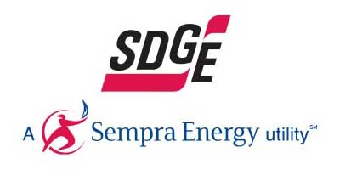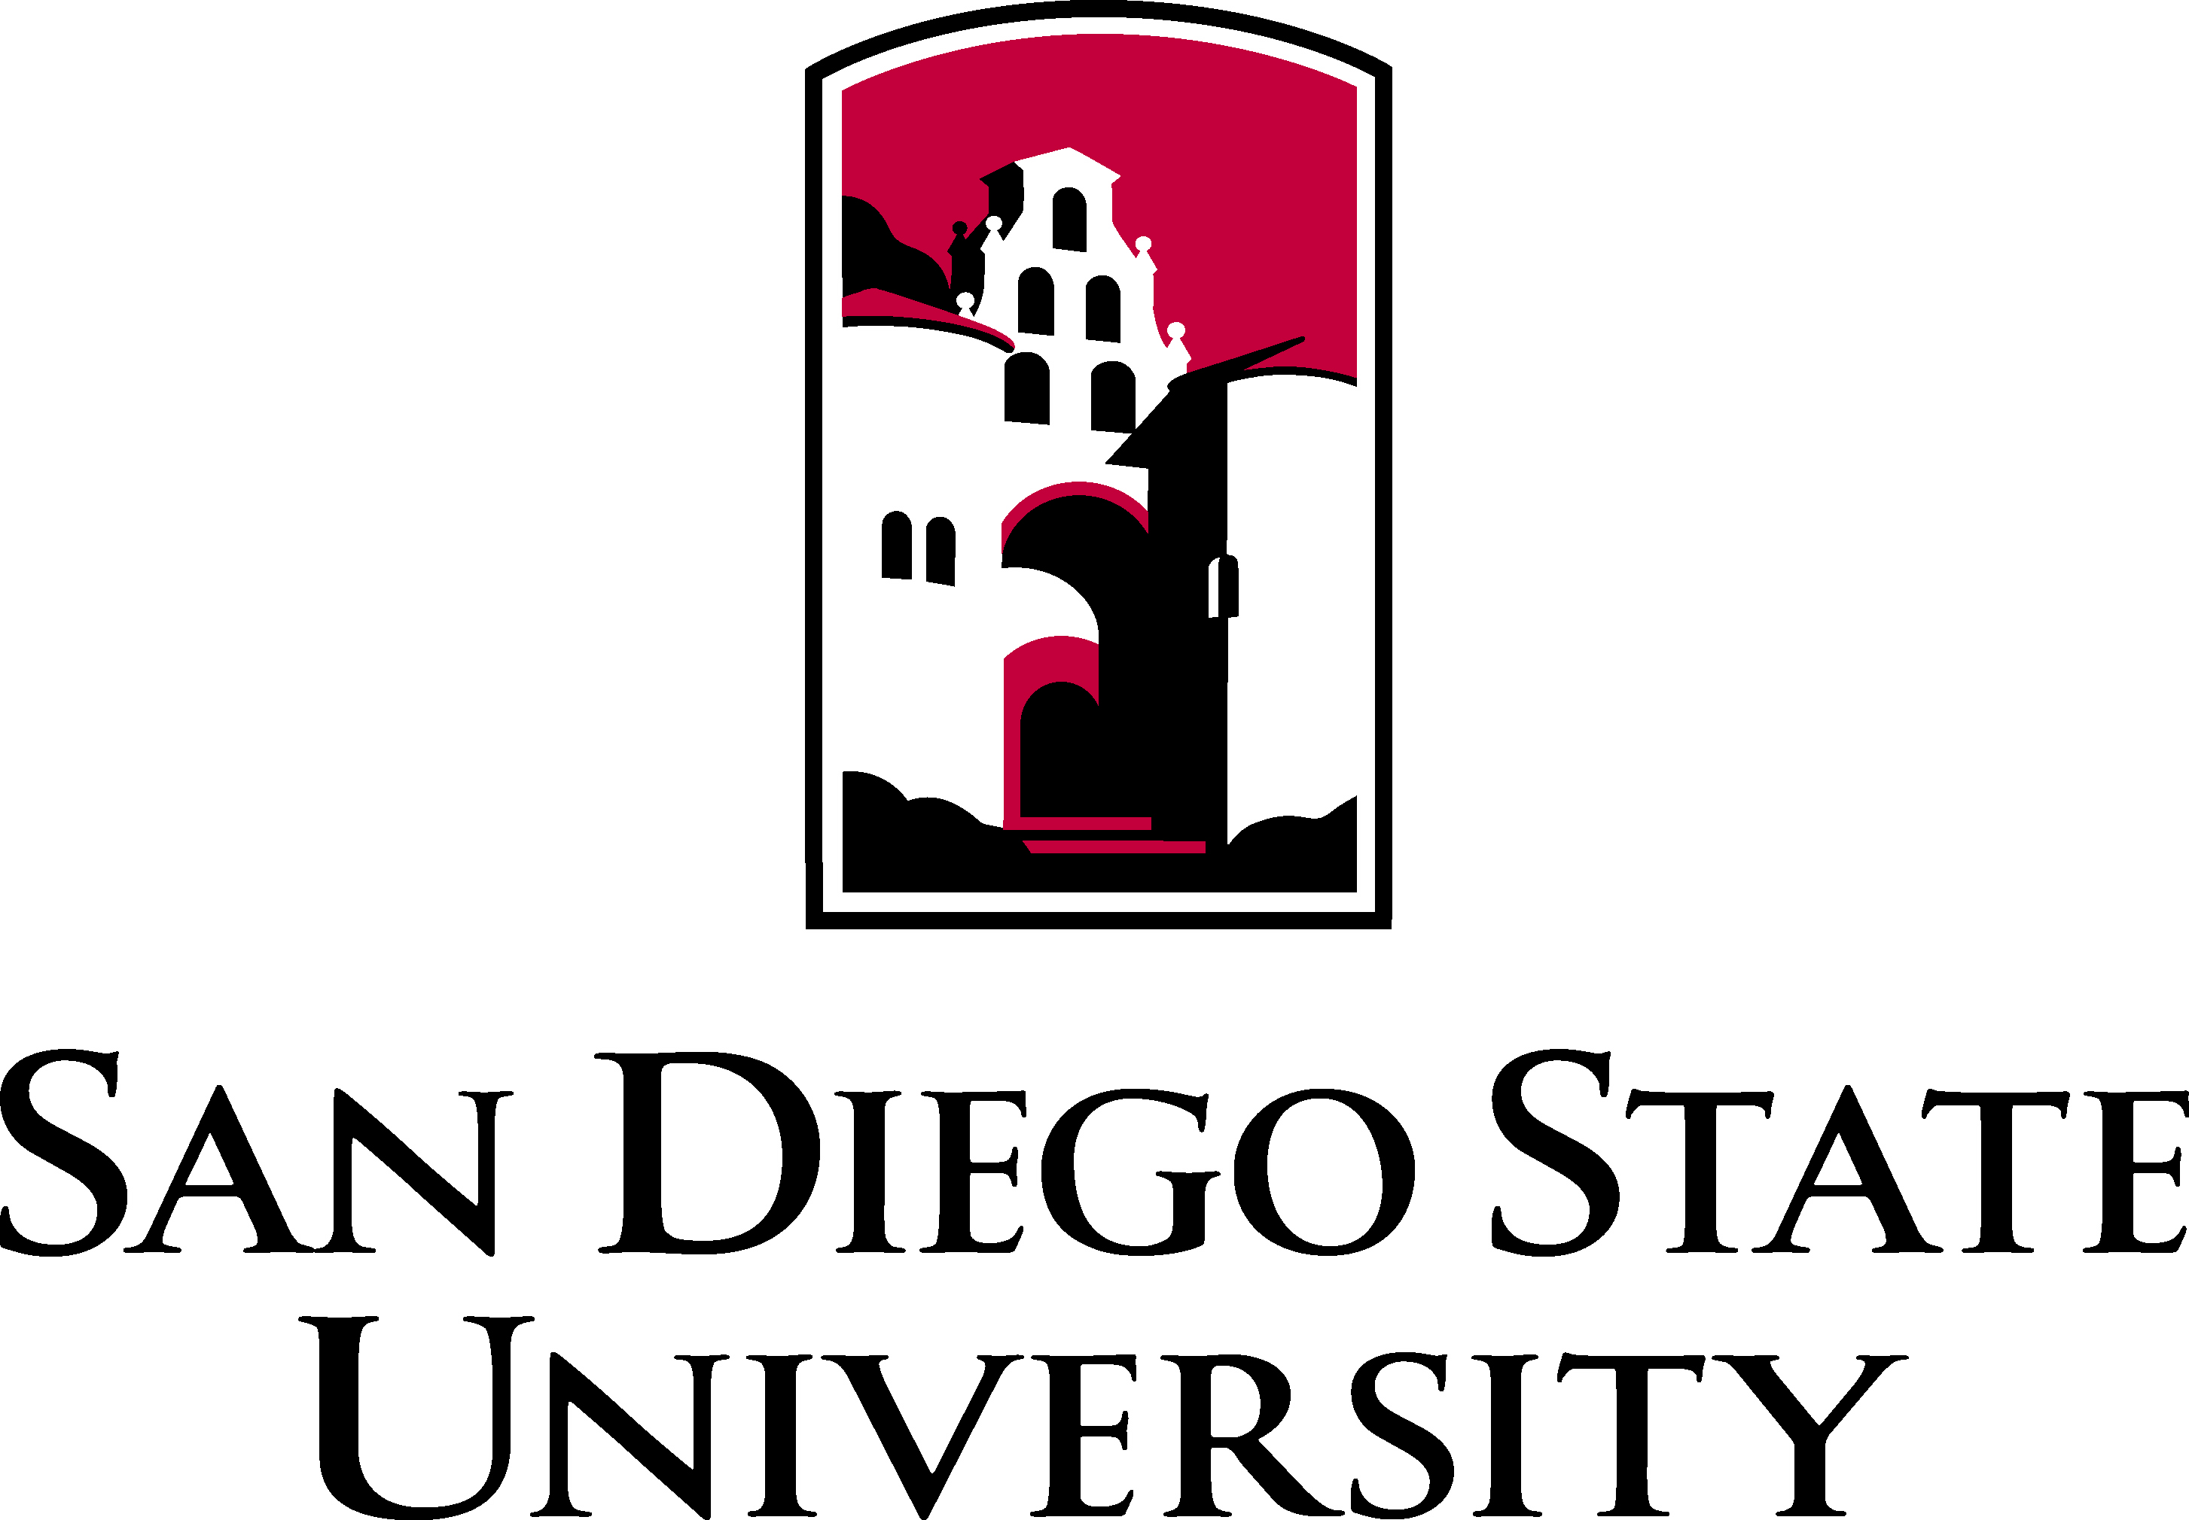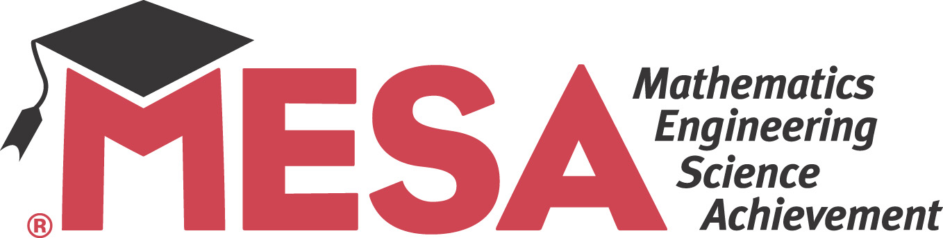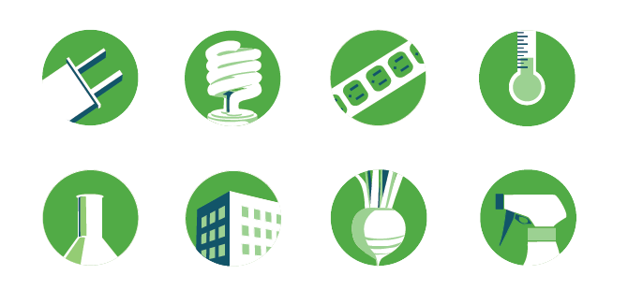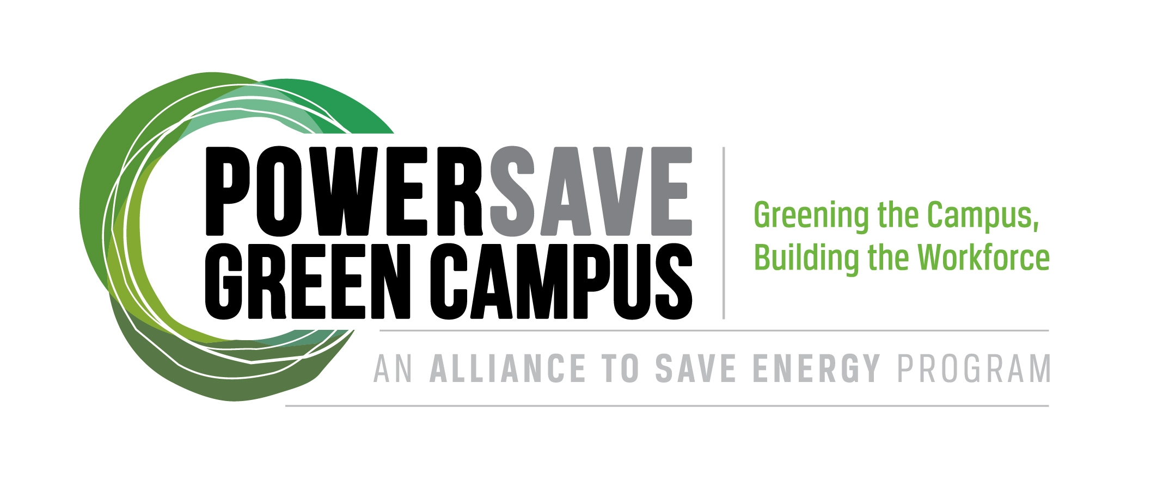

*Do you have an interest in energy efficiency, sustainability, and green career paths? Come to this presentation!*

Kennedy Middle School

900 N 6th Street

El Centro, CA 92243

Saturday February 16, 2013

10:00 – 11:00 am

alliance.sdccmesa.com

